# **Name: Abdurrahman Qureshi**

# **Roll No: 242466**

Practical No: 5

**1) To create a dictionary with any key value pairs .[ 5 elements required in dictionary ]**

CODE:

characters = {

    "Arthur Morgan": "Read Dead Redemption II",

    "Aloy": "Horizon Forbidden West",

    "Ethan Winters": "Resident Evil Biohazard",

    "Trevor Philips": "Grand Theft Auto V",

    "Spectre": "Black Ops III",

    "Simon Riley": "Modern Warefare II",

}

for character, game in characters.items():

    print(f"{game}: {character}")

OUTPUT:

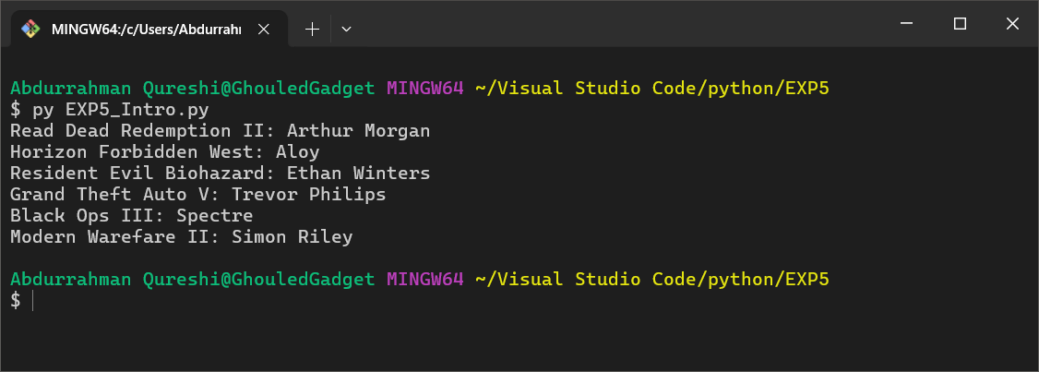

**2)  To create 3 dictionaries using the dictionary comprehension method.**

CODE:

squares = {x: x**2 for x in range(1, 6)}

cubes = {x: x**3 for x in range(1, 6)}

even_odd = {x: "Even" if x % 2 == 0 else "Odd" for x in range(1, 6)}

print("Squares: ", squares)

print("Cubes: ", cubes)

print("Even/Odd: ", even_odd)

OUTPUT:

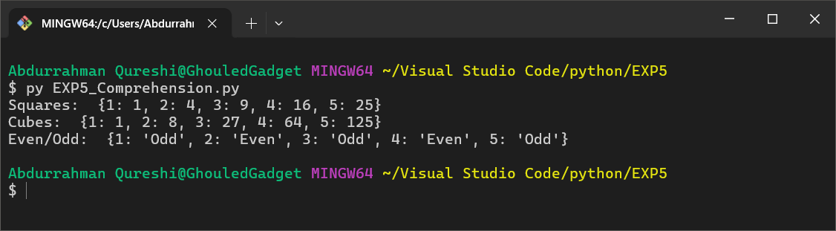

**3) Write a program to demonstrate any 10 methods on dictionary**

CODE:

student_info = {

    "name": "qarq90",

    "roll_no": 242466,

    "branch": "Information Technology",

    "subject": "Python",

    "faculty": "Zainab Mam"

}

print("1. Get Method ('name'):", student_info.get("name"))

print("2. Keys Method:", student_info.keys())

print("3. Values Method:", student_info.values())

print("4. Items Method:", student_info.items())

student_info.update({"college": "Saboo Siddik", "grade": "A"})

print("5. Update Method:", student_info)

removed_value = student_info.pop("subject")

print("6. Pop Method (Removed 'subject'):", removed_value)

print("Updated Dictionary:", student_info)

last_item = student_info.popitem()

print("7. Popitem Method (Removed last item):", last_item)

print("Updated Dictionary:", student_info)

default_value = student_info.setdefault("hobby", "Reading")

print("8. Setdefault Method (Added 'hobby'):", student_info)

copied_dict = student_info.copy()

print("9. Copy Method (Copied Dictionary):", copied_dict)

student_info.clear()

print("10. Clear Method (After Clearing Dictionary):", student_info)

OUTPUT:

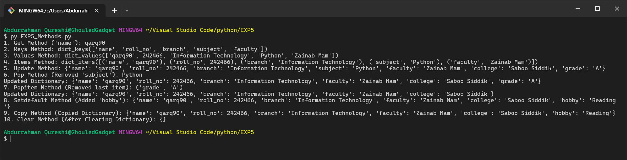

**4) To implement caesar cipher using dictionary (write prg using functions as did earlier)**

CODE:

student_info = {

    "name": "qarq90",

    "roll_no": "242466",

    "branch": "Information Technology",

    "subject": "Python",

    "faculty": "Zainab Mam"

}

def ceaser_cipher(input_text, key, encrypt=True):

    characters = ["A", "B", "C", "D", "E", "F", "G", "H", "I", "J", "K", "L", "M", "N", "O", "P", "Q", "R", "S", "T", "U", "V", "W", "X", "Y", "Z",

                  "a", "b", "c", "d", "e", "f", "g", "h", "i", "j", "k", "l", "m", "n", "o", "p", "q", "r", "s", "t", "u", "v", "w", "x", "y", "z",

                  "1", "2", "3", "4", "5", "6", "7", "8", "9", "0", "/", "+", " "]

    result = ""

    for char in input_text:

        if char in characters:

            index = characters.index(char)

            if encrypt:

                new_index = (index + key) % len(characters)

            else:

                new_index = (index - key) % len(characters)

            result += characters[new_index]

        else:

            result += char

    return result

key = 5

encrypted_info = {k: ceaser_cipher(str(v), key, True) for k, v in student_info.items()}

decrypted_info = {k: ceaser_cipher(v, key, False) for k, v in encrypted_info.items()}

print("Original Dictionary:\n", student_info)

print("\nEncrypted Dictionary:\n", encrypted_info)

print("\nDecrypted Dictionary:\n", decrypted_info)

OUTPUT:

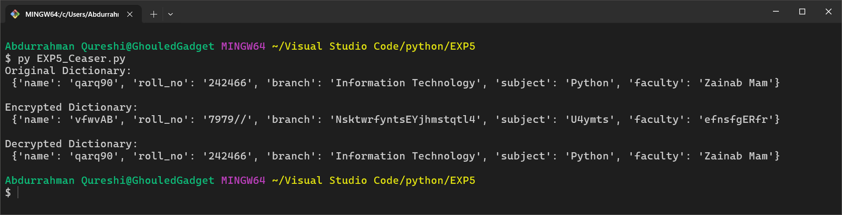

**5) To create a dictionary with any 5 key value pair . Print the dictionary. Add an element in a dictionary and delete an element**

CODE:

dict = {"Name": "qarq90","Roll_no": 242466,"Branch": "Information Technology","Subject": "Python","Faculty": "Zainab Mam"}

print("Original Dictionary:", dict)

dict["College"] = "Saboo Siddik"

print("After Adding an Element:", dict)

del dict["Subject"]

print("After Deleting an Element:", dict)

OUTPUT:

